Skill Tracker Front End

Use Case

Contents

Team Detail 3

Front End Tech Details 3

Project Folder Structure 3

Cypress Folder structure 4

Skill details 4

Skill details - Request / Response: 5

Search 5

By Name: 5

By Associate ID: 6

By Skills 6

Pagination 7

Search API Request / Response 7

Validation: 8

Cypress Implementation 9

Cypress testing with different browsers 9

Edge 9

Electron 10

Firefox 10

Git Details 10

Source Code 11

# Team Detail

Team Name: **Avengers**

Team Members: **Gokulakrishnan.K, Sankara Naryanan.S, SelvaGanapathy.K**

## Front End Tech Details

React, Material-UI, Axios, Lodash and Cypress

## Project Folder Structure

## Cypress Folder structure

## Skill details

Skill details are retrieved from API calls

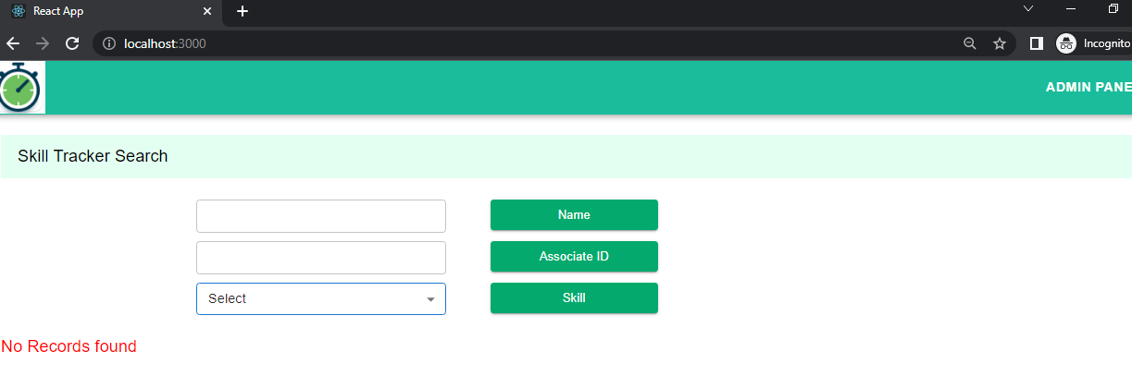

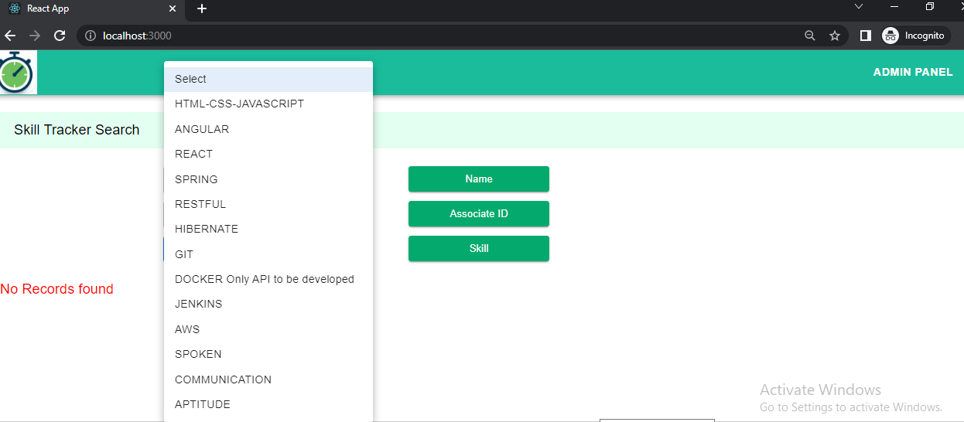

### Skill details - Request / Response:

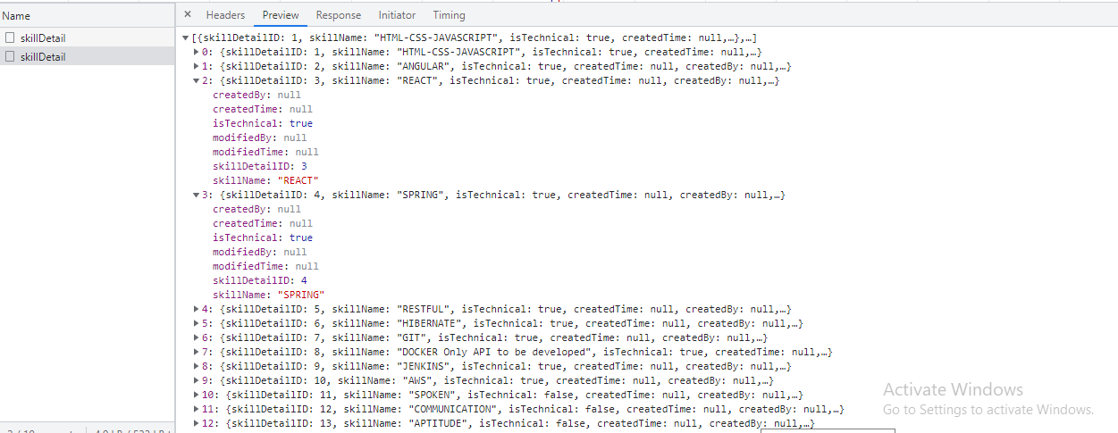

## Search

User can search the skills in three different ways.

### By Name:

User can search the skills based on user name.

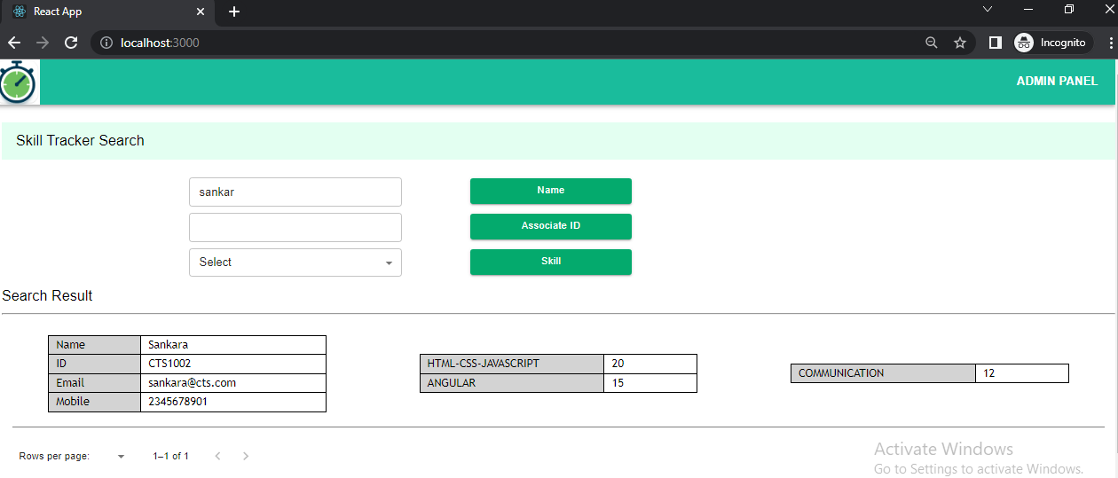

### By Associate ID:

User can search by entering the Asssoicate Id

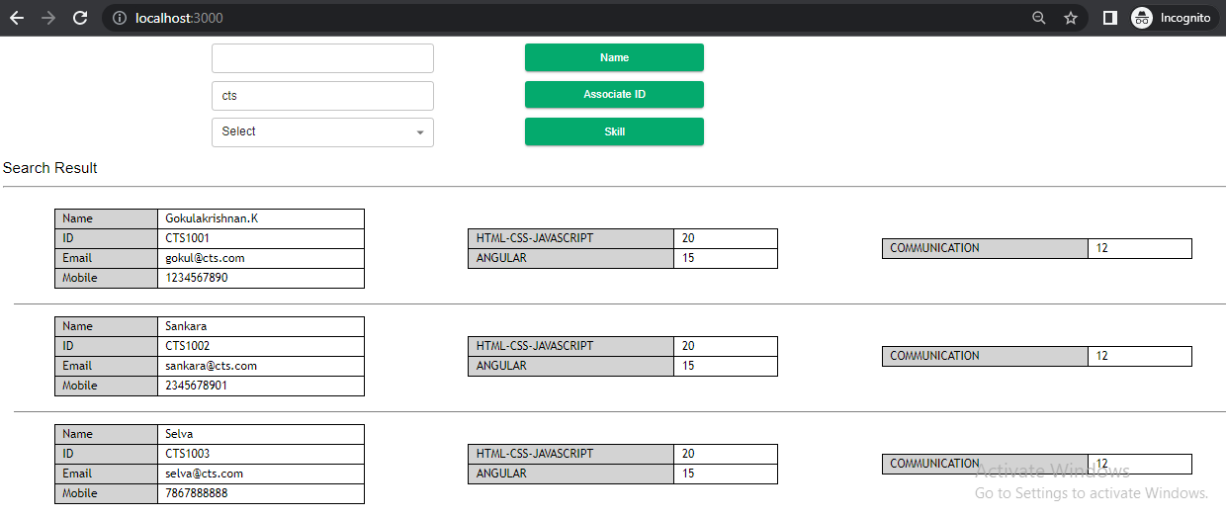

### By Skills

User can search based on associate skills. Here user can pick the skills and search. It will list out all the associates associated with the skils.

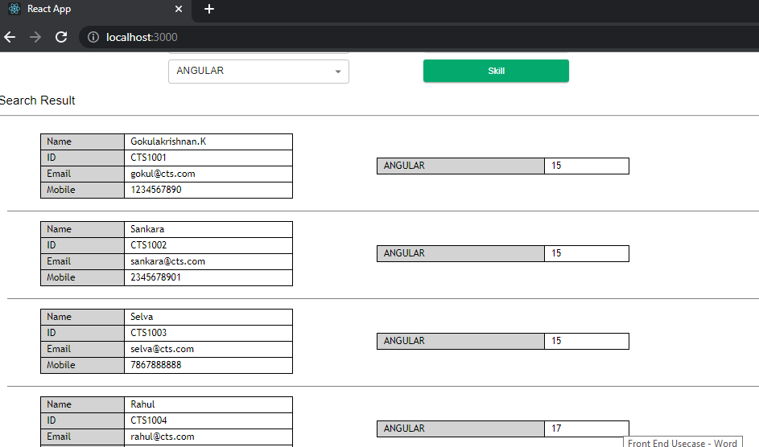

### Pagination

Retrieving all the details from API is not advisable and it will critically impact the API performance. To avoid this and improve the performance, we implemented the paginations. At any point of time, API only returns 10 records. User can either narrow down the search or utilize the pagination to view the associate details.

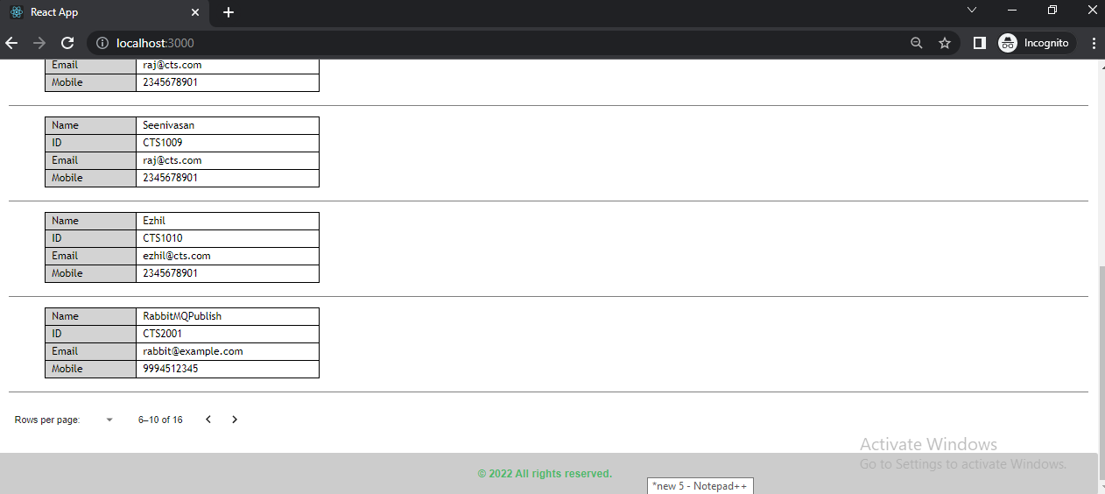

### Search API Request / Response

Below image shows, JSON API response for id search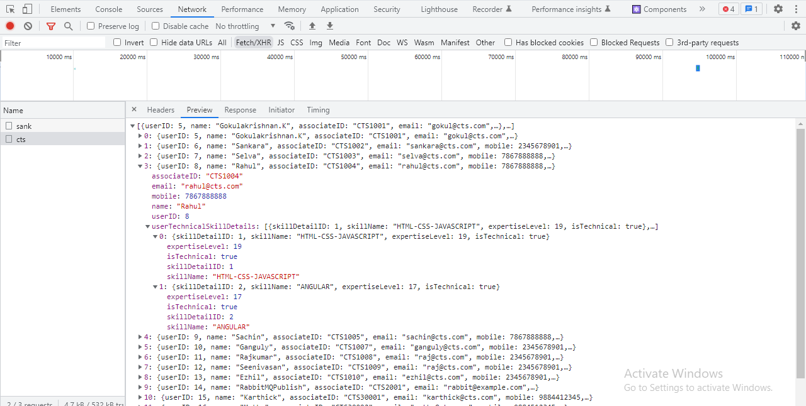

## Validation:

To make the application user friendly, we are providing user friendly validation messages to the user. Also, it should ensure unnecessary API hit.

Below is the sample validation message, user will encounter without entering mandatory values.

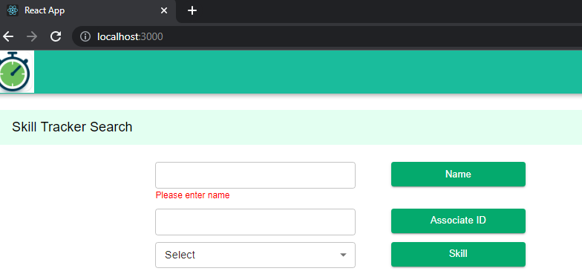

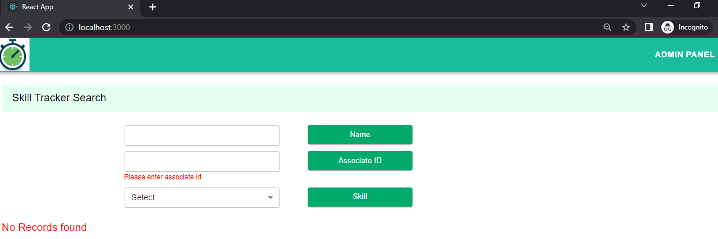

# Cypress Implementation

Validation is the one of the most important parts in development. Without doing end to end testing, even small enhancement would make huge impact. So, to avoid such issues, we incorporated end to end validation for skill tracker application using cypress testing.

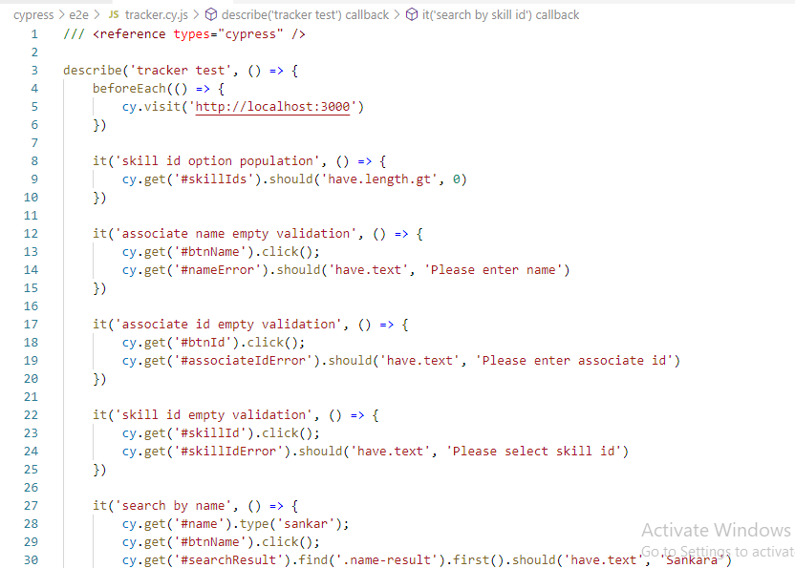

## Cypress testing with different browsers

We ran browser compatibility testing as well, by using different browsers.

### Edge

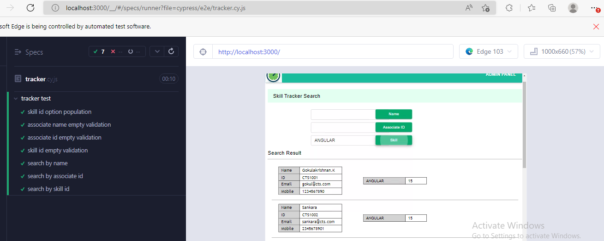

### Electron

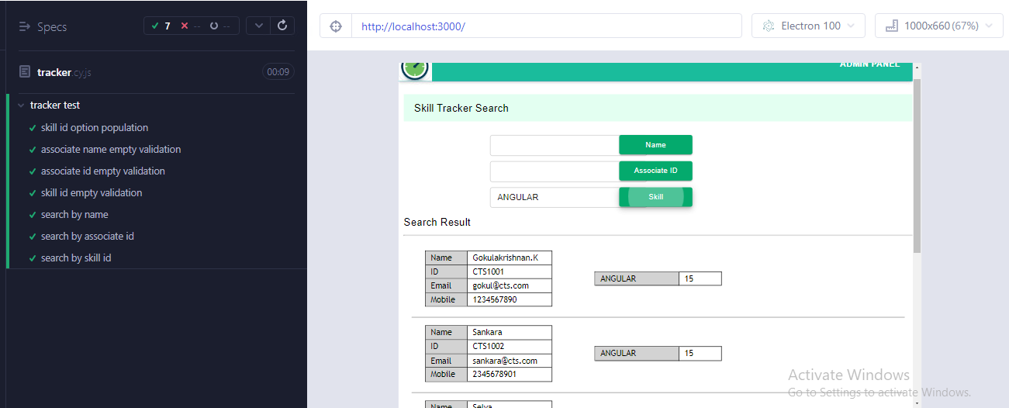

### Firefox

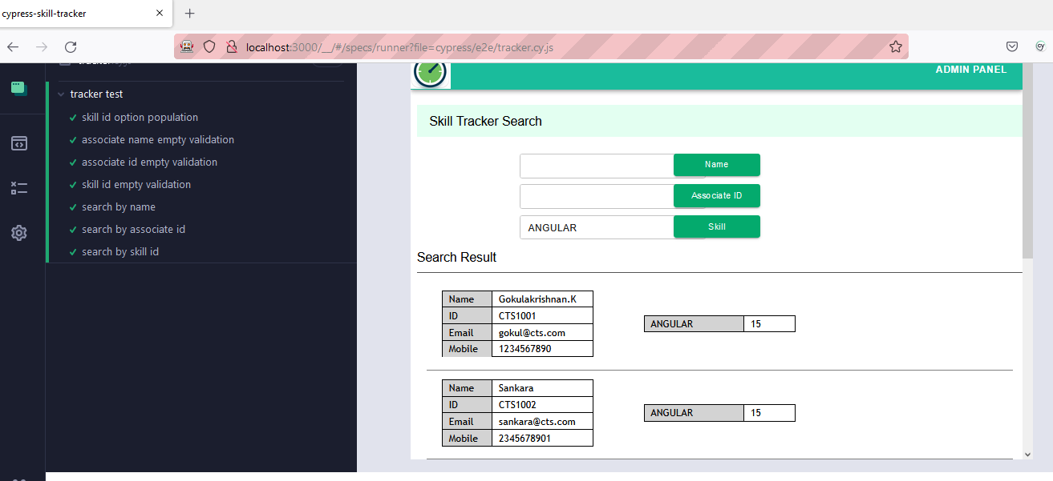

# Git Details

Cypress Git Url: <https://git03.iiht.tech/sankara/cypress-skill-tracker>

UI Git Url: <https://git03.iiht.tech/sankara/skill-tracker-app>

Version History:

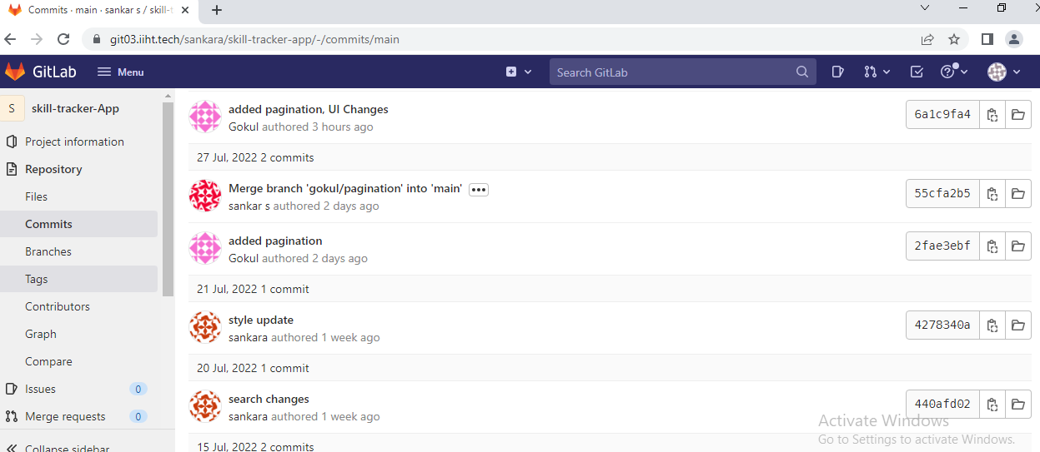

# Source Code



